Asia-China-Coin-Knife Money , Straight Knives-H4.71 r3-H4.72 R 0-Money Model

Length 4.1cm. / 1.61 in., width 11.3 cm. / 4.45 in.

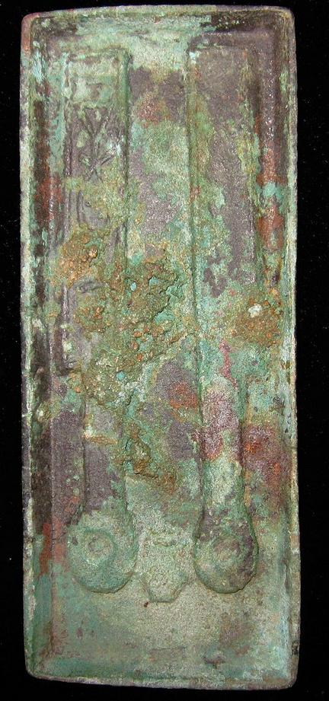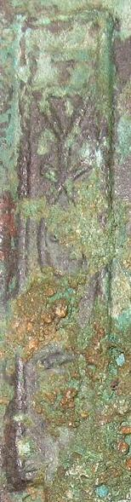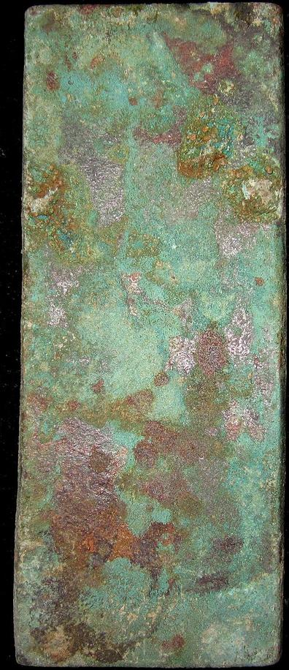

h 4.71

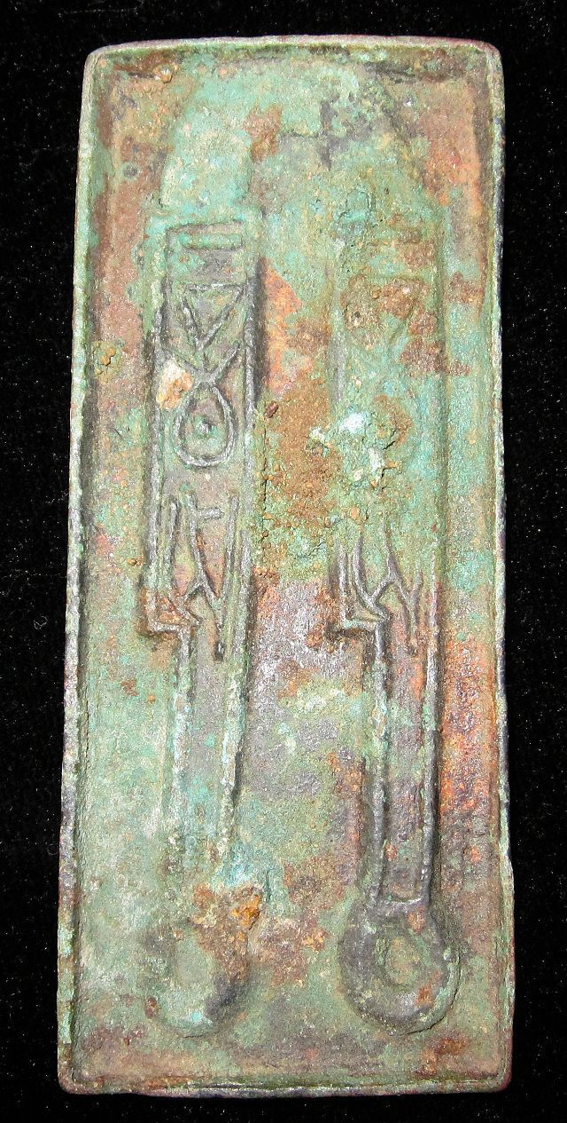 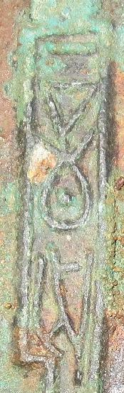 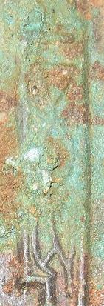

H 4.72 R0, length 3.9 cm./ 1.54 in., width 9.4 cm. / 3.70 in.

